There are still a few things left to cover from the candlestick set we shared last sessions. Tonight, we will continue to finish what we shared in the previous post. Next, I will hand you The Money Making Code of Volume and The Golden Combination of SMAs. This is a complete set of technical ideas to achieve a diversified, multi-indicator resonance technical model combination
This is the perfect trading system for everyone to trade with what is shared each night. On top of the technical basis, we have perfected the theoretical basis. I believe that everyone can become a professional investor in a very short time.
Today, I want to teach you some common candlestick selling patterns, combined with today's content and last week's content. Basically, you will be able to roughly determine whether a stock is worth buying and when to sell. The content is relatively large, and I hope you study carefully.
The first type: The upper hanging line
1. Candlestick chart entity is very small, the upper shadow is very small or almost none, the lower shadow is very large than the entity more than 2 times. of the positive or negative.

2. Appears at the end of an uptrend

3. Hanging candlestick charts are divided into three kinds: rising hanging candlestick charts, falling hanging candlestick charts, and T-shaped hanging candlestick charts
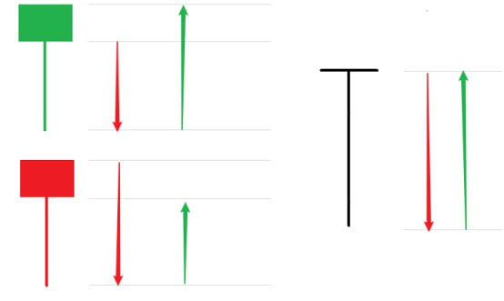
We are comparing the strength of the long and short it is not difficult to find: rising candlestick chart long slightly stronger, falling candlestick chart short slightly stronger, T-shaped candlestick chart long and short flat, hanging candlestick chart entity is very small, the upper shadow line is very small or almost no, the lower shadow line is very long, the long lower shadow line on behalf of the willingness to buy should be regarded as a signal of the long. And no upper lead or small upper lead represents the powerlessness of the long side.

At this time, the power of the short side is close to the power of the long side, and the power of the long side has become quite fragile. At this time, it is easy to appear between the transformation between long and short, and the small solid part of the hanging also represents the possibility of future changes. We only need to go through the confirmation of the future short to determine whether the beginning of the short market.

The confirmation method is to observe the next day's closing price below the "hanging candlestick" entity; the price fell below the hanging entity. The presence of hanging candlesticks means that it is not suitable to open new positions in the short term, and that anyone who buys stocks near the open and close of the day will lose money!
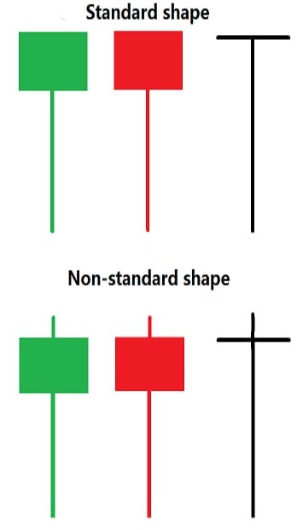
Hanging line pattern appeared, we have to learn to judge is the main force is the plate shock wash or trend flip. Usually, we can use the following methods to observe:
If the market forms a downward candlestick entity the following day and it closes below the closing price of the hanging line, then this negative line serves as confirmation of a trend reversal
Pay attention to the volume at the time of the formation of the hanging line. If the hanging line is accompanied by huge volume, especially if there is recent sky-high volume, be especially alert to the possibility of a one-day reversal. On the contrary, if the hanging line is formed with a significant volume contraction, you need to wait for another confirming signal to appear.
Let's take a look at HINDUNILVR on the daily chart, the 6th of July appeared hanging line candlestick (A), the next day the market opened at a lower level (B), the entity of the hanging line and the hanging line the next day between the opening price of the market down the gap between the larger, this is very typical of the pattern, in line with the first situation we said, then the late HINDUNILVR appeared to fall back significantly!
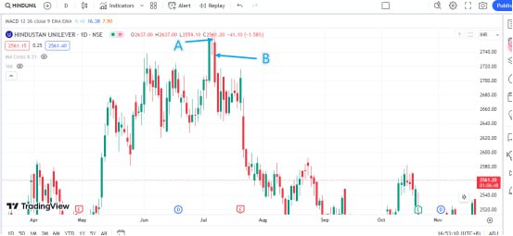
We must remember to hanging candlestick form of the confirmation of the method to avoid stepping into the wrong area, in BHARTIARTL in 23 years in June 3, such as, candlestick form to meet, but the volume of obscene, through the next day to continue to observe its closing price is slightly higher than the closing price of the line on the hanging, so this candlestick does not belong to hanging candlestick, but belongs to the agency washout behavior!
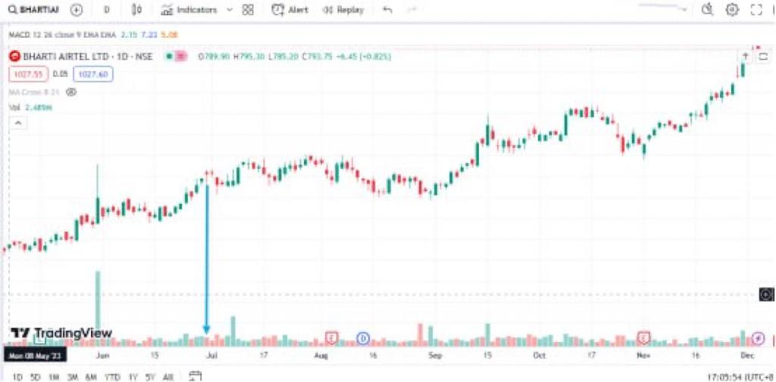
The Hanging Candlestick and Hammer Candlestick patterns are the basis for upward and downward reversal judgements, respectively, and we must have more quantities of them, keeping in mind the contrast between the long and short sides, together with a variety of other elements for analysis and confirmation
The second type: Dark Cloud Cover

1. The first candlestick is a large positive line, to take over the previous upturn.

2. The second candlestick is a large negative line, the closing price deep into the first half of the entity below the large positive line. If all engulfed the entity, it is a bearish engulfing pattern, the implication of a stronger top (described below)
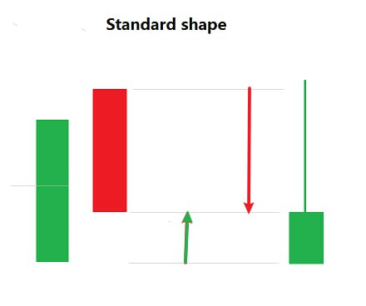
The market was in an uptrend, and a large positive line appeared. The market opened upwards and high on day 2, with buyers in full control. But the market did not continue on the attack, the day's closing price at the day's lowest, or close to the lowest, which means that the market price upward momentum exhausted, the short side of the force began to take control of the decline of the 2nd day of the decline candlestick down through the 1st day of the rising entity of the degree of the deeper, the pattern constitutes the top of the possibility of reversal the greater the number of us to use long and short to compare the way to judge the strength of the short side, it is generally believed that it must be down through the red entity of the 50%.

If the candlestick does not go down through 50% of the previous candlestick's entity, it is necessary to observe the strength of the short side of the later trend.
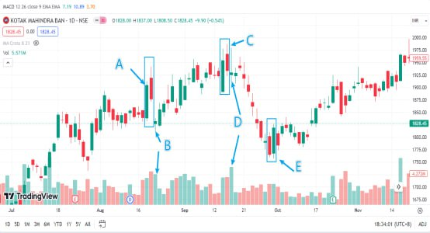
Let's look at KOTAKBANK easy to misjudge the place, in 22 years on 19 August there is a suspected pattern (A), down 50% near (not to) our key point is to observe the next day of the multi-short power, in the 22nd of the day (B) volume did not shrink, multi-short competition is fierce and the long side of the dominance of the market then continued to rise. In looking at C, it also did not fall below 50% of the meaning of the form. Continue to observe the next day D, volume enlarged and short dominant, the market then began to fall back, E at the beginning of the long dominant market turn over!
So a dark cloud cover is a topping sign, signaling that the price may be topping back down. In a period of uptrend, do not be fooled by the big positive line on day 1, but also watch for a downtrend on day 3 to determine the downtrend pattern, especially if it is suspected that it is even more important to spend more time observing the pattern. A standard pattern like SHREEGANES 6 Apr 23 (A) can be judged in time when it is confirmed on the following day.
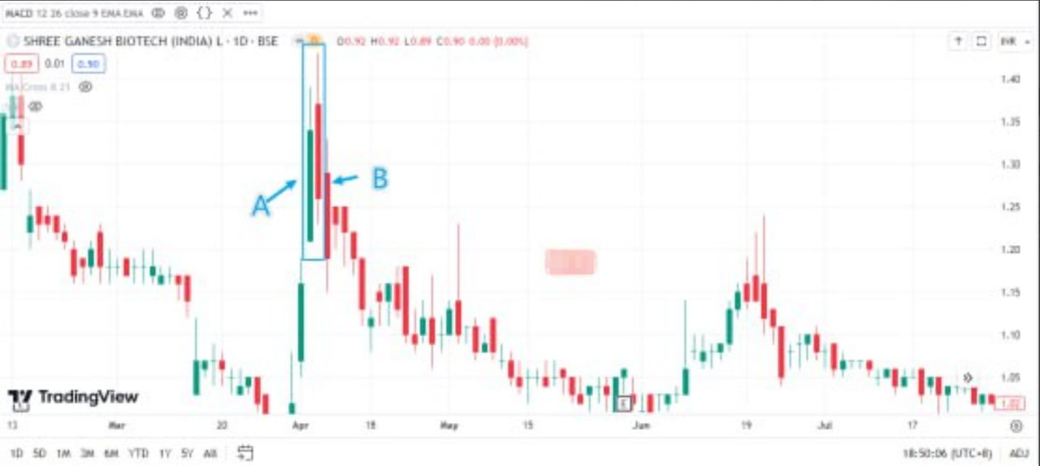
And like in INDIACEM the dark cloud cover pattern did not form (A), but the strength of the short side made us feel worried, we can also continue to do observation, B this day closed through half of the rising candlestick, but the long side seems to be very strong, C this day has been completely penetrated, the performance of the short side is obvious, we can also be regarded as a combination of more than candlestick form, the market continues to fall until the D began to be more than obviously Prevailing, like this short-term decline in the market our support and resistance how to find, we said earlier, the highest point of the key candlestick chart, the market rebounded to touch E key resistance. So we trade, not just familiar with the candlestick pattern, bearing in mind the principle of short and long and trade management, dead memory form will only mislead you, but to the overall technical aspects of the study to improve the chances of winning the deal, which is the correct use of the language of candlestick charts.
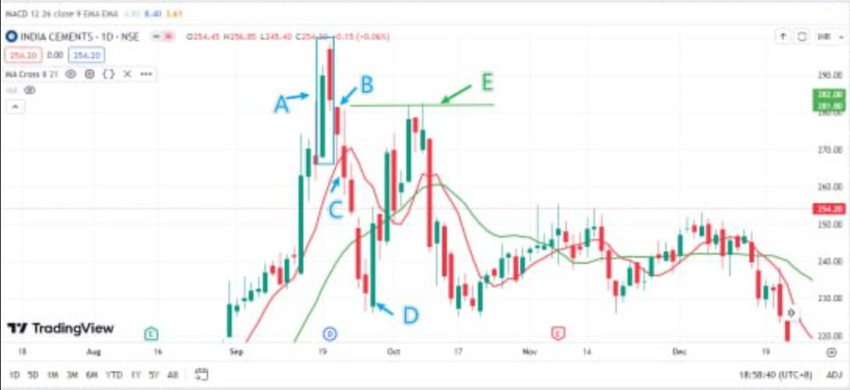
Deformation of the pattern also, the second candle line of the opening price is equal to or slightly lower than the closing price of the first candle line, the closing price of the second candle line is located in the first candle line below 50% of the entity or directly through, we can also be interpreted as the formation of the formation of a strong resistance area through the merger of candlestick charts can be obtained and the same results as the standard pattern (as shown in the figure), so the pattern of the direct nature of the strength of the short and long judgments.
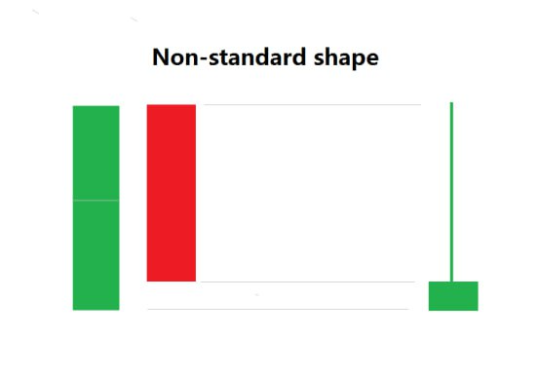
Let's look at the actual use of ASIANPAINT July 23, there is such a deformation of the pattern, the price of late all the way down, and the pattern appeared at the bottom of this candlestick to form a more critical reference point, in the late rally process also appeared to be a good pressure performance!
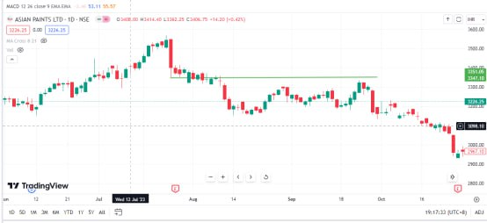
Third type: Bearish Engulfing

1. A bearish engulfing pattern occurs in a clear uptrend, round.

2. The first candlestick should be bullish (up), and the second candlestick should be more bearish (down), completely engulfing the previous candlestick.

3. The greater the decline, the more pronounced the effect.

4. Pay attention to the performance of the volume.
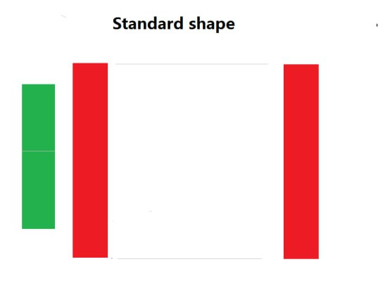
Bearish engulfing pattern and bullish engulfing pattern is just the opposite, the market after a period of rise, the market suddenly appeared a negative line, it will be the previous day's positive line all engulfed, to give people a huge contrast, so that people realize that the power of the short side is relatively strong. So, out of profit-taking considerations, the market began to enter a period of consolidation or rout. We can see in SBIN A out for the more obvious pattern, the next day, B low open low directly determines the pattern is valid!
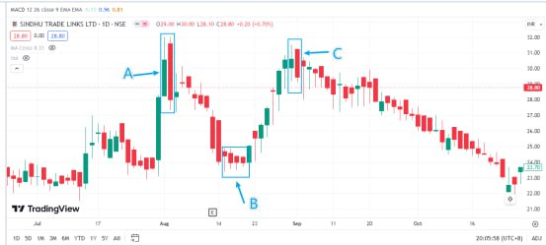
We look at the BHARTIARTL in A, this day appeared engulfing pattern, but the overall pattern is relatively lackluster, the short side seems to be barely dominant, focusing on the volume of shrinkage, the next day B's performance is still more than empty continue to coke, the short side did not have a clear predominance, so the appearance of this form of the time, the late fall may be only a retracement of the performance, when the bulls regained control of the initiative force, the price continues to rise!
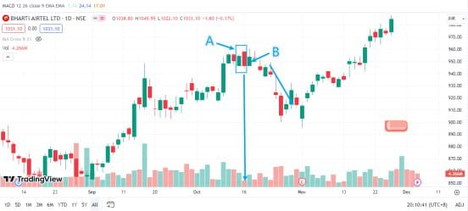
Today, we presented three "Sell Down" candlestick combinations. Due to time limitations, we will continue to share the remaining candlestick patterns during our session tomorrow. Wishing you all a pleasant evening 🤝

